An Energy-Centric Comparative Evaluation of Software-Based vs. Hardware-Accelerated Cryptography on ESP32 in a Realistic IoT Duty Cycle

Submitted By:
Samoda Wijesooriya
IM/2021/059

Supervised By:
Dr. Keerthi Wijayasiriwardhane

A dissertation submitted in partial fulfilment of the requirements for the Degree of Bachelor of Science in Information Technology

Department of Industrial Management
Faculty of Science
University of Kelaniya
Sri Lanka
July 2026

Declaration
I hereby state that this research report and findings presented in it are my own and it has not been submitted before nor is it currently being submitted for any other academic programme. Where material has been used from other sources due recognition has been given by mentioning the source.

Signature of the student
Signature:
Date: 16/07/2026

Signature of Supervisor
Supervisor’s Signature:
Date:

Contents
Declaration ii
List of figures v
List of Tables v
List of Equations v
Chapter 01: Introduction 1
1.1 Overview of the Internet of Things (IoT) 1
1.2 Cryptographic Requirements in Constrained Environment 1
1.3 The Energy-Security Trade-off Software vs Hardware Acceleration 2
1.4 The Importance of Realistic IoT Duty Cycles 2
1.5 Problem in Existing IoT Implementations 3
1.6 Need for Comparative Evaluation 3
1.7 Research Questions 4
1.8 Objectives 4
1.9 Organization of Thesis 5
Chapter 02: Literature Review 6
2.1 Introduction to Cryptography and IoT Security 6
2.1.1 The Evolution of Data Security and Encryption 6
2.1.2 IoT Threat Landscape and Device Constraints 7
2.2 Cryptographic Foundations for IoT 7
2.2.1 Symmetric vs Asymmetric Encryption 7
2.2.2 Role of AEAD in IoT Security 8
2.2.3 Common IoT Encryption Methods 8
2.2.4 AES and AES-GCM 9
2.2.5 Lightweight Cryptography: The ASCON Standard 10
2.3 Software-Based vs Hardware-Accelerated Cryptography 10
2.3.1 Principles and Trade-offs of Software Cryptography 10
2.3.2 Principles and Trade-offs of Hardware Cryptographic Engines 11
2.3.3 The ESP32 Hardware Accelerator 11
2.3.4 Comparative Literature: Software ASCON vs Hardware AES 12
2.4 Evaluation Methodologies for Energy-Centric Benchmarking 13
2.4.1 Metrics and Benchmarking Practices 13
2.4.2 Measurement Techniques and Instrumentation 14
2.5 Realistic IoT Duty Cycles and Energy Implications 14
2.5.1 Duty Cycle Structure (Sleep → Wake → Sense → Transmit → Sleep) 15
2.5.2 Sleep Implementation Mechanisms 16
2.6 Synthesis of Comparative Evidence 16
2.7 Research Gap and Justification 17
3.1 Research Process 19
3.1.1 Research Methodology 19
3.2 Selection of Cryptographic Algorithms 20
3.2.1 Rationale for AES-128-GCM 20
3.2.2 Rationale for ASCON-128 20
3.2.3 Common Evaluation Basis 21
3.3 Experimental Design 21
3.3.1 Overview of the Measurement Program 21
3.3.2 Payload Generation Strategy 24
3.3.3 Nonce Generation 24
3.3.4 Duty-Cycle/ Sleep Design 25
3.4 Test-bed Implementation 25
3.4.1 Hardware Components 26
3.4.2 Software Environment and Libraries 28
3.4.3 Schematic Diagram 29
3.4.4 Wiring Diagram and Physical Setup 30
3.5 Measurement Methodology 31
3.5.1 Execution Time Measurement 31
3.5.2 Throughput Calculation 31
3.5.3 Power Consumption Measurement 32
3.5.4 Memory Footprint Measurement 32
3.6 Data Collection and Extraction 32
3.7 Expected Data Analysis and Statistical Evaluation 33
3.7.1 Statistical Methods and Tools 33
3.7.2 Significance/Comparison Method 34
11. References 35

List of figures
Figure 1 - Main Algorithm 26
Figure 2 - Functional Block Diagram of ESP32 29
Figure 3 - Simplified Schematic of INA219 30
Figure 4 - Test Bed Side View 31
Figure 5 - Schematic Diagram 32
Figure 6 - Test Bed 33

List of Tables
Table 4 - Summary of Evaluation Metrics and Methodologies 26

List of Equations
Equation 1 - Throughput Equation 36
Equation 2 - Total Power Equation 37

Chapter 01: Introduction

1.1 Overview of the Internet of Things (IoT)
The Internet of Things (IoT) represents a transformative paradigm in modern technology, characterized by a vast network of physical objects, or "things," embedded with sensors, software, and other technologies that connect and exchange data with other devices and systems over the Internet [F. Thabit, 2023]. The exponential growth of IoT has been remarkable; the number of connected IoT devices globally reached 21.1 billion in 2025 and is projected to surge to nearly 39 billion by 2030 [Sinha, 2025]. These smaller embedded devices operate within constrained environments, often in remote or inaccessible locations such as agricultural fields, industrial machinery, or environmental monitoring stations. Because of these devices are frequently deployed in inaccessible or hazard locations, replacing or recharging their batteries is highly impractical. This massive interconnected device necessitates robust and secure communication channels to protect the sensitive data being transmitted across heterogeneous networks. Consequently, optimizing the consumption of every available resource particularly energy is a primary design imperative in IoT systems.

1.2 Cryptographic Requirements in Constrained Environment
As IoT devices increasingly handle sensitive data and control critical infrastructure, securing their communication channels has become more important than anything else. Unsecured IoT networks are highly vulnerable to eavesdropping, data tampering, and device spoofing [Sadhu et al., 2022]. To ensure confidentiality, integrity, and authenticity, cryptographic primitives such as Advanced Encryption Standard (AES), Secure Hash Algorithm (SHA) families, and emerging Lightweight Cryptography (LWC) standards like ASCON are employed [Turan et al., 2025].
However, the mathematical complexity inherits in these encryptions and hashing algorithms demand significant computational overhead. Traditional cryptographic standards, while highly secure, were designed for resource-rich environments and can rapidly consume the limited energy reserves of a constrained IoT devices if not carefully implemented [Kumar & Sethi Ericsson, 2019]. These necessitates a careful evaluation of which cryptographic approaches yield the optimal balance between security and energy efficiency.

1.3 The Energy-Security Trade-off Software vs Hardware Acceleration
A critical factor in the energy consumption of IoT cryptography is the implementation method: software-based execution vs hardware-accelerated execution. Microcontrollers like the ESP32 features a dual-core processor capable of running cryptographic algorithms purely in software. Alternatively, modern System-on-Chip (SoC) designs often include dedicated hardware cryptographic accelerators, specialized silicon blocks designed to execute specific algorithms (like AES or SHA) much faster than the main CPU [Jin & Becker, 2022].
While hardware acceleration theoretically reduces the active execution time of cryptographic operations, it introduces additional wake-up latencies and may draw higher peak currents. Conversely, highly optimized software implementations might run longer but could maintain a lower, more stable power draw. Evaluating whether the time-savings of hardware acceleration actually translate to net energy savings requires a granular, energy-centric analysis rather than a simple speed benchmark [Kietzmann et al., 2021]. For instance, research on ESP32 hardware acceleration has shown significant throughput improvements (e.g., +257.8% for AES encryption), but the total energy impact across a full duty cycle remains a critical area of study [Jin & Becker, 2022].

1.4 The Importance of Realistic IoT Duty Cycles
Historically, many cryptographic evaluations on IoT devices measure only the active execution time or the average current draw during continuous operations. However, this does not reflect a realistic IoT duty cycle. In practical scenarios IoT devices spend the majority of their time in deep sleep mode to conserve battery, waking up only briefly to sense data, perform cryptographic operations, and transmit payloads [Khriji et al., 2022].
In a realistic duty cycle, the energy overhead of transitioning from sleep to activate states, the idle leakage current during the cryptographic execution, and the baseline sleep current of the microcontroller become dominant factors. Therefore, an accurate evaluation of cryptographic energy efficiency must be conducted within the context of a full, realistic IoT duty cycle, measuring the total energy consumed from the moment the device wakes up until it return to deep sleep [Kozłowski & Sosnowski, 2019]. For example, a typical sensor node waking up every 5 minutes may spend only 3 seconds active (drawing ~100mA) and 297 seconds in deep sleep (drawing ~10μA), making the cryptographic overhead during the active phase highly influential on the overall battery life [Community, 2026].

1.5 Problem in Existing IoT Implementations
Although modern microcontrollers such as the ESP32 include dedicated hardware encryption accelerators, much IoT security research continues to emphasize lightweight software-based cryptography such as ASCON. While lightweight ciphers are designed for portability and reduced computational overhead, they remain CPU-bound and can impose significant energy and performance costs within realistic IoT duty cycles. This creates a paradox: developers and researchers prioritize lightweight cryptography for constrained devices yet may overlook built-in hardware engines that can offload encryption tasks, reduce latency, and improve energy efficiency. The lack of systematic studies comparing hardware-accelerated AES-128-GCM with software-based lightweight cryptography (ASCON-128) across realistic IoT duty cycles leaves a critical gap in understanding the true trade-offs among per-byte energy consumption, execution time, throughput, and memory usage on the ESP32 platform.

1.6 Need for Comparative Evaluation
Despite the availability of hardware encryption accelerators in microcontrollers such as the ESP32, systematic comparisons with modern software-based lightweight cryptography across full IoT duty cycles remain limited. While traditional standards like AES-128 GCM are widely deployed and hardware-optimized for speed, they can still be resource-intensive in terms of power and memory depending on the implementation [Radhakrishnan et al., 2024]. In contrast, ASCON-128 has been selected as the NIST primary standard for lightweight cryptography specifically because its 320-bit permutation-based sponge architecture is designed to offer robust Authenticated Encryption with Associated Data (AEAD) with minimal overhead in constrained environments [Kandi et al., 2023]. This research addresses this gap by evaluating whether software-based ASCON can outperform hardware-accelerated AES in low-power, battery-operated IoT nodes [Radhakrishnan et al., 2024].
This study builds upon the methodology established by Amirkhanova et al. (2026a), who demonstrated a practical end-to-end encrypted pipeline using AES-GCM on the ESP32 but identified critical limitations in their own work, including a narrow benchmark scope and a failure to quantify energy and CPU utilization. By expanding this scope, this research implements a realistic IoT duty cycle consisting of Sleep → Wake → Sense → Encrypt → Transmit → Sleep which accurately reflects how real-world devices manage their limited battery life rather than operating continuously [Ciuffoletti, 2022], [Hatch, 2025]. Furthermore, this study directly addresses the future work suggested by prior literature by providing granular, per-byte energy and CPU analysis [Amirkhanova et al., 2026].

1.7 Research Questions
This study seeks to address the following central question: How does hardware-accelerated AES-128-GCM on the ESP32 compare with software-based ASCON-128 in terms of power consumption, memory usage, throughput, execution time, and per-byte energy efficiency when evaluated across a full IoT duty cycle (Sleep → Wake → Sense → Encrypt → Transmit → Sleep)?
By answering this question, the research aims to determine whether leveraging the ESP32’s built-in cryptographic accelerators provide a more energy-efficient and practical security solution for IoT devices than relying solely on lightweight software cryptography.

1.8 Objectives
- To compare the power consumption (total duty-cycle energy) and per-byte energy efficiency of ASCON-128 implemented in software with AES-128-GCM using hardware acceleration on the ESP32 platform, including the initialization overhead of the hardware engine.
- To measure the energy cost per transmitted byte across a realistic IoT duty cycle (Sleep → Wake → Sense → Encrypt → Transmit → Sleep for both cryptographic approaches.
- To determine the conditions (e.g., payload size, duty-cycle frequency, and available energy budget) under which software-based ASCON-128 remains preferable despite the availability of hardware-accelerated AES-128-GCM, including identifying any break-even (crossover) payload size where one approach becomes more energy efficient than the other.

1.9 Organization of Thesis
This thesis is systematically organized into distinct chapters, each serving a specific purpose in presenting the research work comprehensively:
Chapter 1: Introduction – Introduces the fundamental concepts of IoT and highlights the critical role of secure communication in constrained environments. It establishes the research problem by framing the energy–security trade-off in cryptographic implementations and sets the foundation for the comparative evaluation presented in subsequent chapters.
Chapter 2: Literature Review – Provide a survey the existing body of the research on IoT security, cryptographic standards, and evaluation methodologies. It synthesizes prior findings to highlight the unresolved trade-offs between lightweight software cryptography and hardware-accelerated AES within realistic IoT duty cycle.
Chapter 3: Methodology – Outlines the experimental methodology, detailing the IoT duty-cycle testbed, encryption pipeline, and measurement setup for comparing hardware-accelerated AES-128-GCM with software-based ASCON-128.

Chapter 02: Literature Review

2.1 Introduction to Cryptography and IoT Security
Cryptography has evolved from ancient historical methods to standardized digital algorithms that provide the essential framework for securing modern global communications. Symmetric encryption became the cornerstone of modern data protection following the establishment of the Advanced Encryption Standard (AES) by NIST in 2001. These cryptographic primitives are designed to uphold the CIA triad confidentiality, integrity, and availability by serving as a primary defense against eavesdropping and man-in-the-middle attacks across wireless and cloud infrastructures. The ongoing transition toward post-quantum algorithms reflects the critical need for cryptography to adapt to emerging threats while safeguarding the integrity of digital societies.
A major constraint of these traditional standards is that they were primarily optimized for high-performance desktop and server environments, where computational resources and power are abundant. Applying these heavy digital standards directly to the limited architectures of the Internet of Things creates a significant performance gap that requires specialized solutions.

2.1.1 The Evolution of Data Security and Encryption
As security requirements extended beyond desktop and server environments into resource-constrained IoT deployments, the field began shifting away from a "one-size-fits-all" cryptographic model. Rather than treating AES and RSA as universally deployable standards, researchers increasingly recognized that device class not just threat model should determine algorithm choice. This shift gave rise to a distinct research effort around lightweight cryptography (LWC), purpose-built for constrained hardware rather than adapted from server-grade primitives after the fact. The specific mechanics and measured performance of this shift what LWC standards like ASCON actually achieve, and how they compare to legacy alternatives are examined in detail in 2.2, since evaluating those claims requires first establishing the constraints they are designed to solve.

2.1.2 IoT Threat Landscape and Device Constraints
The rapid expansion of the Internet of Things has created a massive attack surface composed of billions of heterogeneous devices that operate under severe resource constraints, significantly increasing their vulnerability to exploitation. IoT endpoints typically utilize low-power microcontrollers clocked between 8 MHz and 32 MHz with on-chip RAM restricted to the 4 KB to 64 KB range, and even capable platforms like the dual-core 240 MHz ESP32 are frequently deployed under minimalist conditions [Faisal Abdullah Althobaiti, 2025]. These devices must often sustain operations for months or years on small coin-cell (~100 mAh) or Li-ion batteries without maintenance, yet executing traditional RSA-2048 operations can consume several seconds of processor time and rapidly deplete energy reserves. Furthermore, because these nodes are often deployed in unstaffed environments and linked via wireless protocols like LoRa or WiFi, they are inherently exposed to eavesdropping and physical tampering, while traditional transport-layer security often fails to account for the massive energy overhead of complex handshakes or the risk posed by untrusted MQTT brokers Bideh et al., 2020].
A critical limitation in the current literature is the frequent reliance on software simulations or analytical models that omit physical hardware factors such as start-up energy costs and realistic hardware duty cycles, rather than measurements taken on real, deployed hardware [Nkemeni et al., 2023; Dezfouli et al., 2018]. This gap between simulated and real-world energy behavior is not incidental.
Because resources are limited, security features are often turned off to make devices last longer. This raises the question of which cryptographic method works best under such limits.

2.2 Cryptographic Foundations for IoT

2.2.1 Symmetric vs Asymmetric Encryption
Symmetric and asymmetric encryption offer distinct trade-offs between performance and key management scalability for IoT environments. Symmetric ciphers are generally preferred for low-power IoT implementations because they utilize a single shared key for rapid encryption and decryption with minimal computational overhead [Agugliaro et al., 2024]. In contrast, asymmetric methods like RSA or ECC improve key management but require significant processing time and memory, often exceeding the budgets of the most constrained devices [Ibrahim et al., 2025]. Current literature indicates that while 256-bit ECC offers security comparable to RSA-3072, the computational cost of asymmetric operations remains thousands of times higher than symmetric block ciphers on 8-bit or 16-bit microcontrollers [Faisal Abdullah Althobaiti, 2025].
A significant drawback cited by researchers is the "k Kings puzzle" of secure key distribution at scale for symmetric schemes, while pure asymmetric solutions are acknowledged as prohibitively energy-consuming for autonomous sensor nodes [Ibrahim et al., 2025]. This imbalance the need of a hybrid approach where asymmetric primitives handle trust establishment and symmetric primitives manage bulk data protection.

2.2.2 Role of AEAD in IoT Security
Authenticated Encryption with Associated Data (AEAD) provides a unified mechanism for ensuring both data secrecy and message integrity within a single cryptographic operation AEAD is critical for IoT because common application protocols like CoAP and MQTT do not include native security features, leaving payloads vulnerable to interception or tampering [Bideh et al., 2020]. By processing associated data; such as network headers, alongside the payload in a single pass, AEAD schemes like AES-GCM or ASCON-128 fulfill confidentiality and authenticity requirements more efficiently than traditional two-pass constructions that require separate HMAC functions [Padmanabha1 et al., 2025]. On ARM Cortex-M0+ platforms, these integrated suites have been shown to reduce cryptographic energy burdens from roughly 35% to under 8% of the total energy budget [Albert, 2026]. While authors claim AEAD improves efficiency, they note that the resulting ciphertext expansion and tag overhead can still impact performance in narrow-band LPWAN technologies where payloads are extremely small [Faisal Abdullah Althobaiti, 2025]. The transition from basic block ciphers to AEAD suites is central to modern IoT security standards.

2.2.3 Common IoT Encryption Methods
Algorithm | Type | Security Strength | Primary focus/ Trade-off
AES-128 | Symmetric (Block) | 128-bit | Legacy standard; robust but resource-intensive in software
RSA-2048 | Asymmetric | High | Standardized PKI; prohibitive energy drains for IoT
ECC (Curve25519) | Asymmetric | High | Efficient key exchange; better than RSA but still slower than symmetric
SPECK-64/128 | Symmetric (Block) | 128-bit | Software-oriented; ultra-low resource requirements
ASCON-128 | Symmetric (AEAD) | 128-bit | Purpose-built LWC standard; minimal memory and power
Table 1 - Common IoT Encryption Methods
This table reveals a clear cluster around AEAD-capable symmetric algorithms, which prioritize reducing the "security-performance gap" for real-time sensing. While asymmetric methods like ECC solve identity and key distribution problems, they represent a distinct trade-off of high memory usage and latency that limits their use to infrequent handshake operations [Agugliaro et al., 2024]. This pattern underscores a research shift toward purpose-built lightweight symmetric standards like ASCON over legacy desktop-oriented algorithms.

2.2.4 AES and AES-GCM
The Advanced Encryption Standard remains the most widely trusted symmetric primitive, though its iterative design claims were originally optimized for high-performance processors. Standardized by NIST in 2001, AES utilizes a 128-bit state matrix and a 10-round schedule of complex algebraic transformations to provide robust defense against differential and linear cryptanalysis [Farooq et al., 2020]. When combined with the Galois Counter Mode (GCM), it offers high-speed authenticated encryption through binary field multiplication, though it requires significant RAM and CPU cycles that can rapidly deplete coin-cell batteries [Kim et al., 2020]. Design-level claims emphasize the algorithm's agility and simplicity for hardware-independent security [Farooq et al., 2020].
Despite its design claims, researches acknowledge that standard software-emulated AES on low-power microcontrollers lacking native hardware vector units introduces severe cycle execution overhead and high latency [Ridho Rabbani, 2025]. This makes AES a heavyweight-but-accelerable legacy option that often relies on dedicated silicon to bridge its performance gap.

2.2.5 Lightweight Cryptography: The ASCON Standard
ASCON was purpose-built to provide the highest levels of security within the minimal resource envelopes typical of low-power sensor nodes. Selected as the NIST lightweight standard in 2023, the ASCON family utilizes a 320-bit permutation-based sponge architecture that performs AEAD and hashing in a single pass [Turan et al., 2025]. ASCON claim that it balances throughput and memory use by employing bit-sliced 5-bit S-boxes, which reduces hardware gate counts compared to the 8-bit S-boxes used in AES [Ridho Rabbani, 2025]. It is intended for devices with less than 32 KB of RAM, aiming for a code footprint below 10 KB [Faisal Abdullah Althobaiti, 2025].
While ASCON focus on optimizing efficiency through lightweight permutation rounds, practical measurements show that its sponge duplexing introduces linear runtime scaling [Ridho Rabbani, 2025]. As payload increase, this iterative structure can lead to slower performance in extended bulk stream operations when hardware acceleration is not available.
The extend which of these algorithm-level characteristics are realized is strongly influenced by the mode of implementation, whether executed in software or supported through dedicated hardware.

2.3 Software-Based vs Hardware-Accelerated Cryptography

2.3.1 Principles and Trade-offs of Software Cryptography
Software-based cryptography offers maximum flexibility and ease of deployment but places a significant burden on the limited computational and memory resources of IoT microcontrollers. Software implementations on general-purpose microcontrollers using lightweight libraries like mbedTLS or TinyCrypt maximize flexibility, supporting over-the-air patches and algorithm agility without hardware redesign [Faisal Abdullah Althobaiti, 2025]. However, these implementations demand higher CPU load and RAM, which increases latency in real-time control loops and rapidly depletes battery reserves [Faisal Abdullah Althobaiti, 2025]. For example, standard symmetric suites introduce severe instruction cycle overhead when software-emulated on low-power microcontrollers lacking native hardware vector units [Ridho Rabbani, 2025].
As [Ridho Rabbani, 2025] said major constraint in software cryptography research is that benchmarks often rely on optimized C/assembly libraries in isolation, failing to account for the additional overhead induced by the overall software stack or the specific compiler configurations used in production environments. This resource-intensive nature of software emulation drives the integration of dedicated hardware components to offload the cryptographic burden.

2.3.2 Principles and Trade-offs of Hardware Cryptographic Engines
Dedicated hardware cryptographic engines provide superior energy efficiency and speed but introduce a rigid architecture that cannot adapt to evolving security standards. Hardware accelerators, such as ASICs or dedicated coprocessors, can reduce cryptographic energy consumption per operation by 50% to 80% compared to software-only implementations [Faisal Abdullah Althobaiti, 2025]. Empirical tests on ARM Cortex-M3 platforms confirm that storing AES matrixes in hardware significantly reduces power consumption and calculation requirements [Hung & Hsu, 2018]. However, building these special-purpose modules requires massive initial investment, and unlike software, they are nearly impossible to update once deployed "in the wild," risking total obsolescence if a primitive is compromised or security parameters change [Devadas et al., 2022]. Much of the hardware-focused literature relies on post-synthesis simulations or high-end Field-Programmable Gate Array (FPGA) models that do not reflect the specific bus latencies and invocation costs encountered in mass-produced microcontrollers [Al-Shmailawi et al., 2026]. While highly efficient, the lack of flexibility in fixed silicon necessitates evaluating platforms that combine hardware acceleration with programmable cores, such as the ESP32.

2.3.3 The ESP32 Hardware Accelerator
The ESP32 platform incorporates native hardware peripherals to bridge the performance gap between time-tested security standards and the constraints of low-power IoT sensing. The ESP32 series features integrated hardware encryption accelerators that support AES, SHA-256, RSA, and RNG [Al-Mashhadani & Shujaa, 2022]. Leveraging these built-in coprocessors for AES operations enables the device to maintain real-time performance with encryption latencies under 3 milliseconds while keeping CPU usage stable at 35–45% [Rafat et al., 2025]. This allows the platform to support advanced security protocols like TLS 1.2 and authenticated communication via ESP-NOW without the prohibitive power drain associated with software-emulated block ciphers [Bideh et al., 2020].
Authors acknowledge that if hardware peripherals are not explicitly invoked by the specific library version (e.g., certain builds of mbedTLS), the system may default to software emulation without alerting the developer [Ridho Rabbani, 2025]. The availability of both native hardware modules and the capacity for software-optimized ciphers on a single platform creates a conflict in the literature regarding the most efficient path forward.

2.3.4 Comparative Literature: Software ASCON vs Hardware AES
Current research presents conflicting conclusions on whether purpose-built lightweight software standards or hardware-accelerated legacy algorithms provide the optimal security foundation for the IoT. Proponents of lightweight cryptography demonstrate that software-based ASCON-128 can cut execution latency by 74% compared to software-emulated AES-128 on identical ESP32 silicon [Ridho Rabbani, 2025]. Furthermore, ASCON variants often outperform software AES in throughput and energy efficiency across various Arduino-based 32-bit platforms [Tripathi et al., 2024]. Conversely, other literature maintains that the presence of dedicated hardware accelerators, such as those in the ESP32 or LAUNCHXL-CC1310, makes legacy standards like AES practical and far more efficient than any software-only alternative [Rafat et al., 2025;Hung & Hsu, 2018].
The literature is not unified on which approach is superior, and the disagreement is traceable to what is actually being compared rather than to a genuine conflict in evidence. Studies reporting ASCON's superiority [Ridho Rabbani, 2025] benchmark it against software-implemented AES, where ASCON's lower computational overhead gives it a clear advantage. Studies reporting hardware-accelerated AES's superiority [Hung & Hsu, 2018;Rafat et al., 2025], by contrast, compare it against the same software AES baseline being offloaded to silicon not against ASCON at all. No reviewed study directly benchmarks software ASCON-128 against hardware-accelerated AES-128-GCM on the same platform. This means the "AES vs ASCON" debate and the "software vs hardware" debate have proceeded largely in parallel, and their intersection precisely the comparison this thesis performs remains empirically untested. Resolving this requires examining how existing studies actually measure and compare these approaches and whether those measurements are even comparable to one another.

2.4 Evaluation Methodologies for Energy-Centric Benchmarking

2.4.1 Metrics and Benchmarking Practices
The absence of a standardized metric framework for evaluating cryptographic performance leads to fragmented data that prevents equitable comparisons between legacy and lightweight algorithms. Current literature utilizes a diverse array of performance indicators, including energy-per-encrypted-kilobyte, cycles-per-byte, and composite "target functions" that assign weighted values to CPU cycles, initialization time, and memory usage [Ibrahim et al., 2025]. To address this fragmentation, [Jin & Becker, 2022] established a foundational benchmarking approach specifically for the ESP32 platform, providing a structured framework for transforming raw hardware measurements into numerical evidence to accurately assess the relationship between cryptographic overhead and resource utilization. These comparisons are further complicated by inconsistent definitions of "code size," with some studies including decryption and key-scheduling routines while others measure encryption in isolation [Beaulieu et al., 2013]. For example, performance evaluations of the ASCON family often emphasize a balance between throughput and memory footprint, whereas AES benchmarks frequently prioritize raw execution speed without accounting for the RAM-to-energy trade-offs essential for constrained devices [Al-Shmailawi et al., 2026].
Researchers themselves acknowledge that differing assumptions; such as the exclusion of key management overheads or the use of different cell libraries; make direct "fair comparisons" across studies highly problematic [Beaulieu et al., 2013]. This methodological inconsistency explains why the AES-vs-ASCON debate remains unresolved, as the reported "superiority" of an algorithm is often a byproduct of the specific metrics prioritized by the investigators.

2.4.2 Measurement Techniques and Instrumentation
Variation in measurement approaches from high-precision physical analyzers to software-based simulations introduces environmental factors and instrumentation noise that complicate accurate assessment of the true energy demands of IoT security. Measurement setups in the literature range from specialized side-channel evaluation boards (SASEBO) and high-cost industrial tools like Otii Arc to low-cost custom platforms such as EMPIOT [Dezfouli et al., 2018]. A significant portion of existing research continues to rely on analytical models or simulators (e.g., CupCarbon) that frequently omit critical hardware factors such as start-up energy costs, MAC-layer complexities, and voltage stabilization effects [Mahdi & Abdullah, 2025]. Differences in hardware fidelity imply that reported energy savings may not be replicated on physical ESP32 nodes, where factors such as battery discharge behavior and radio interference substantially shape the overall power profile [Mahdi & Abdullah, 2025].
The research community explicitly identifies that many existing tools suffer from limited current measurement ranges or low accuracy when capturing the rapid, high-power spikes characteristic of cryptographic bursts and wireless transmissions [Dezfouli et al., 2018]. Recent methodological advancements by [Mitchel et al., 2025] mitigate these accuracy concerns by standardizing high-precision timing through the micros() API and defining rigorous throughput formulas designed to isolate computational latency from serial communication noise. Furthermore, their work introduces essential statistical treatments for cleaning raw logs, providing a structured process to remove experimental noise and mitigate the impact of random spikes or background system processes. These inconsistencies become especially consequential once real-world duty-cycle behavior is considered, not just isolated encryption operations.

2.5 Realistic IoT Duty Cycles and Energy Implications
The energy profile of a field-deployed IoT node is primarily defined by its duty cycle the ratio of time spent in low-power sleep states versus active processing rather than by cryptographic operations in isolation. In realistic scenarios, such as environmental sensing or precision agriculture, devices operate in a cyclic pattern: transitioning from deep sleep to a brief wake-up phase for sensing and data processing before transmitting results and returning to sleep [Gerndt et al., 2025]. Research indicates that for nodes aiming for multi-year lifespans on coin-cell batteries, the duty cycle is typically kept very low, often under 13%, meaning the device spends over 85% of its existence in a dormant state [Aydin et al., 2011]. Consequently, the total energy budget is dominated by the cumulative cost of these sleep intervals and the significant transient energy spikes incurred during the state transitions between sleep and active modes [Dezfouli et al., 2018].
A significant methodological gap exists where duty-cycle models frequently omit the "start-up energy cost" the power consumed as voltage stabilizes and peripherals initialize which can be higher than the energy required for actual data transmission [Junchao Ma, 2009]. This suggests that lab-bench benchmarks focusing on single, continuous encryption operations fail to account for the transient overheads that define the true energy landscape of a deployed IoT node.

2.5.1 Duty Cycle Structure (Sleep → Wake → Sense → Transmit → Sleep)
The discrete phases of an IoT duty cycle introduce diverse power demands that must be managed collectively to ensure system longevity. The cycle begins with a wake-up trigger either an internal timer or an external interrupt followed by a "transient" startup process where the radio and oscillator initialize, typically consuming around 22 µJ over 2.1 ms [Nkemeni et al., 2023]. Once active, the node performs sensing and computation, such as running a Kalman filter, where current draw on an ESP32 can jump from 300 µA in sleep to over 36 mA [Nkemeni et al., 2023]. The final active phase involves radio transmission, which represents the most power-intensive burst, before the node executes a "turndown" sequence to re-enter a sleep state [Junchao Ma, 2009].
Most experimental evaluations of these cycles are validated only via simulations, with very few studies performing physical measurements on laboratory testbeds to verify how specific application-layer tasks, like encryption, impact the total cycle duration [Nkemeni et al., 2023]. Understanding these distinct phases reveals that encryption is merely one component of a broader energy chain, necessitating its evaluation within the context of the entire active window.

2.5.2 Sleep Implementation Mechanisms
Advanced sleep modes, particularly deep sleep and hibernation, are essential for reducing the baseline current consumption of IoT platforms during periods of inactivity. The ESP32 provides several power-saving tiers, including modem sleep, light sleep, and deep sleep, with the latter reducing current consumption to as low as 10 µA–150 µA by shutting down the CPU, Wi-Fi, and Bluetooth [Mac et al., n.d.]. In deep sleep, the only active components are the Real-Time Clock (RTC) and the Ultra-Low Power (ULP) coprocessor, which can be programmed to monitor sensors and trigger a full system wake-up only when specific thresholds are met [Syahmi Md Dzahir & Seng Chia, 2023]. Utilizing these mechanisms has been shown to improve battery runtime by over 500% compared to systems that remain in a continuous idle state Syahmi Md Dzahir & Seng Chia, 2023].
A critical technical constraint of deep sleep is that RAM contents are lost upon entry, forcing the microcontroller to undergo a full reboot and potentially costly algorithm re-initialization whenever it wakes up [Gerndt et al., 2025]. The necessity of re-initializing security parameters after every sleep cycle highlights a hidden energy cost that is often ignored in standard cryptographic benchmarks.

2.6 Synthesis of Comparative Evidence
The current body of literature presents a fragmented landscape where the perceived superiority of a cryptographic approach depends largely on the level of analysis and the conditions of implementation. At the algorithmic level, purpose-built lightweight standards like ASCON-128 are consistently championed for their streamlined sponge constructions and bit-sliced designs, which are claimed to bridge the "security-performance gap" that legacy block ciphers cannot meet [Ridho Rabbani, 2025). However, this algorithm-centric view frequently conflicts with implementation-level research, which demonstrates that the energy and latency penalties of the Advanced Encryption Standard (AES) are effectively neutralized when offloaded to dedicated hardware accelerators [Hung & Hsu, 2018].
This fundamental conflict remains unresolved because the literature lacks a uniform methodological foundation. The disagreement over whether software-based lightweight standards or hardware-fixed legacy standards are more sustainable is often a byproduct of inconsistent metrics and disparate instrumentation. While some studies prioritize raw execution latency on 32-bit platforms, others focus on gate counts in ASIC simulations or energy-per-byte in isolated software libraries [Dezfouli et al., 2018]. Furthermore, the reliance on software-only baselines in ASCON performance profiles often ignores the "X-factor" of native silicon acceleration available on mass-produced platforms like the ESP32, leading to a research landscape where the two most viable paths for IoT security are rarely measured on an equitable field [Ridho Rabbani, 2025].
Finally, a critical disconnect persists between cryptographic benchmarking and the operational reality of the Internet of Things. Nearly all reviewed studies evaluate encryption as a continuous, isolated operation, failing to situate these results within a realistic hardware duty cycle. By ignoring the transient energy spikes of wake-up phases, the "start-up cost" of peripherals, and the cumulative impact of sleep-state transitions, existing research provides an incomplete picture of how algorithm choice actually influences the total energy budget and longevity of a battery-powered node [Nkemeni et al., 2023].

2.7 Research Gap and Justification
Despite the volume of research into lightweight cryptography and hardware acceleration, a significant empirical gap remains: no reviewed study performs a direct, head-to-head comparison between software-based ASCON-128 and hardware-accelerated AES-128-GCM under identical, realistic IoT duty-cycle conditions using a uniform energy-per-byte metric. While proponents of ASCON benchmark it against software-emulated AES to prove its speed, and hardware researchers benchmark silicon-based AES against software-based AES to prove its efficiency, the intersection of these two domains comparing the new software standard against the legacy hardware standard on the same platform remains empirically untested [Ridho Rabbani, 2025].
This gap is significant because the absence of comparative data forces developers into a dangerous trade-off between security posture and device sustainability. If the energy overhead of legacy standards is overestimated, developers may disable security features entirely to preserve battery life, leaving devices vulnerable to botnet-driven DDoS attacks and firmware exploits. Conversely, if a "lightweight" software standard is adopted without accounting for its behavior during rapid sleep-wake transitions, it may inadvertently deplete energy reserves faster than a hardware-fixed alternative, causing premature system failure in inaccessible or hostile environments where battery replacement is impractical. Resolving this contradiction is essential for establishing a sustainable security foundation that can extend theoretical device lifetimes by years while maintaining robust, standardized protection for the global IoT ecosystem.

Chapter 03: System Design and Methodology

3.1 Research Process
This study adopts a quantitative research framework grounded in a positive paradigm, assuming that performance metrics are objective realities that can be empirically verified through structured experimentations. This thesis prioritized the collection of numerical evidence, provide statistically significant insights into the behavior of the cryptographic algorithms under study. The approach of [Jin & Becker, 2022 facilitates the transformation of raw hardware measurements into structured analytical tools, such as comparative tables and performance graphs, to accurately assess the relationship between cryptographic overhead and resource utilization. An experimental strategy is utilized to collect data in standardized units of measurement, allowing pre-defined framework to interpret data, rather than building theory from observations.

3.1.1 Research Methodology
The methodology developed for this research significantly extends the foundational benchmarking approach established by [Jin & Becker, 2022], which primarily focused on execution time and throughput. While Jin and Becker's work provided critical baseline performance data, this study expands that scope by introducing power consumption and realistic duty cycle dimensions to assess the total energy impact of cryptographic operations. Furthermore, this thesis explicitly addresses the limitations identified in recent literature by [Amirkhanova et al., 2026], which noted that many prior end-to-end pipelines fails to quantify energy utilization or CPU overhead beyond basic latency. The investigation is specifically designed to evaluate the performance of hardware-accelerated AES-128-GCM against the software-based ASCON-128 standard. These algorithms are assessed using a comprehensive set of metrics, including throughput, memory allocation, and energy cost per transmitted byte. To ensure the findings reflect actual IoT operational conditions, these variables are measured across the full lifecycle consisting of sleep, wake-up, sensing, encryption, and transmission phases. To address the identified gap, this investigation incorporates per-byte energy efficiency analysis, normalizing power consumption across varying payload sizes.

3.2 Selection of Cryptographic Algorithms
The selection of cryptographic algorithms for this evaluation is designed to compare the established global "gold standard" against the emerging standard for lightweight security in the Internet of Things (IoT). For this purpose, AES-128-GCM and ASCON-128 were chosen as the two primary candidates [Amirkhanova et al., 2026; Fernández-García & Jiménez-Fernández, n.d.]. This selection allows the research to analyze the performance gap between a traditional block cipher that benefits from native ESP32 hardware acceleration and a modern lightweight cipher optimized for efficiency in software-only environments.

3.2.1 Rationale for AES-128-GCM
AES-128 was retained as the symmetric baseline for this study to ensure comparability with a vast body of prior literature evaluating the ESP32’s hardware-acceleration capabilities. However, this research transitions from commonly used Cipher Block Chaining (CBC) mode to Galois Counter Mode (GCM). The primary rationale for choosing GCM is that it provides Authenticated Encryption with Associated Data (AEAD), which integrates confidentiality and message integrity into a single cryptographic pass. By utilizing AES-128-GCM, the study can measure the maximum efficiency of the ESP32’s dedicated hardware engine when performing the authenticated encryption tasks required for secure industrial communication.

3.2.2 Rationale for ASCON-128
ASCON-128 is implemented as the primary lightweight comparison point against the hardware-accelerated AES baseline. Selected by NIST in 2023 as the global standard for lightweight cryptography, ASCON is explicitly designed for resource-constrained devices where traditional algorithms may be too compute-intensive [Fernández-García & Jiménez-Fernández, 2024]. Unlike AES, the ESP32 does not possess a dedicated hardware accelerator for ASCON, which allows this research to isolate the performance impact of hardware acceleration versus a purely software-optimized lightweight cipher. This comparison is vital to determine whether the algorithmic efficiency of ASCON in software can match or exceed the energy-saving benefits of legacy hardware-offloading for AES.

3.2.3 Common Evaluation Basis
To strengthen the methodological rigor of the comparative evaluation, a controlled-variable design is utilized. All environmental factors, including payload generation, the timing method, and the duty cycle, are held constant across both AES and ASCON implementations.
The table below summarizes the evaluation methods for each metric.
Metric | Description | Measurement Method/ Tool
Execution Time | The total duration required to complete a single cryptographic operation (encryption or decryption). | Measured using the built-in micros() function, capturing microsecond-resolution snapshots before and after each operation.
Throughput | The volume of data processed per unit of time, expressed in bytes per second (B/s). | Calculated using the formula:  Throughput = Bytes in payload / mean execution time(s)
Power Consumption | The real-time electrical energy drawdown during active cryptographic processing. | Monitored via an INA219 current sensor, allowing for the tracking of milliampere-hours (mAh) or microjoules (µJ) per operation.
Memory Footprint | The impact of the cryptographic algorithm on the device's volatile memory (RAM). | Captured using the ESP.getFreeHeap() function to measure the difference in available heap memory before and after the process.
Table 2 - Summary of Evaluation Metrics and Methodologies
The evaluation is conducted within the ESP-IDF (Espressif IoT Development Framework), the official software development environment for the ESP32 SoC, which provides the necessary libraries and low-level hardware access for accurate benchmarking [Al-Mashhadani & Shujaa, 2022].

3.3 Experimental Design
The experimental design is structured to facilitate a granular, energy-centric comparison between hardware-accelerated and software-based cryptographic primitives. The framework integrates performance benchmarking with power profiling across a realistic IoT lifecycle, ensuring that the results reflect actual operational conditions rather than continuous, high-power execution.

3.3.1 Overview of the Measurement Program
The measurement program follows a structured logic to capture the computational and energy overhead of cryptographic operations on the ESP32 platform. As illustrated in the Main Setup and Nested Loop Control flowchart, the process begins by selecting the encryption algorithm (hardware-accelerated AES-128-GCM or software-based ASCON-128) and defining the corresponding cryptographic key. Once a stable Wi-Fi connection is established for data reporting, the system enters a dual-nested loop structure designed for high statistical granularity.
- Outer Loop (): Executes 500 iterations per data point to ensure statistical stability and mitigate the impact of transient system noise.
- Inner Loop (): Iterates through 100 varying payload sizes (where ranges from 1 to 100), enabling the study to evaluate performance scaling across a broad range of data volumes.
Each iteration of the inner loop triggers a single RUN_TRIAL sequence. As defined in the Payload Generation algorithm, the system dynamically creates a message where the Size = 16 * j resulting in payloads ranging from 16 bytes to 1,600 bytes. To ensure reproducibility, these payloads are generated using a Pseudo-random Number Generator (PRNG) seeded with a constant value of 128.
Prior to encryption, a unique nonce is generated for every message to maintain cryptographic integrity. According to the GENERATE_NONCE flowchart, the system applies algorithm-specific lengths: a 12-byte nonce for AES-128-GCM, consistent with GCM standards, and a 16-byte nonce for ASCON-128.
ENCRYPT_AND_MEASURE function capture core performance data. This activates a power and memory monitor immediately before the encryption function and stops it precisely upon cipher termination. To quantify the total energy cost of security within a realistic IoT duty cycle, the program executes a SLEEP_AND_MEASURE routine following each encryption trial. This process encompasses the following stages:
- Baseline Monitoring: Power monitoring is initialized to capture the sleep-state draw
- Deep Sleep: The ESP32 enters a 60-second deep sleep phase, significantly reducing current consumption by powering down the CPU and radio
- Wake-up and Reconnection: Following the sleep interval, the device wakes up and executes a RECONNECT_WIFI() command

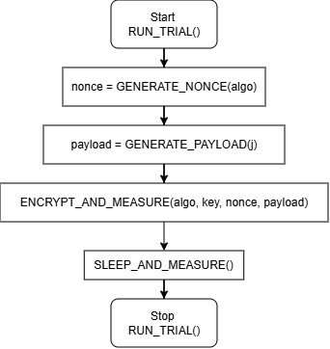
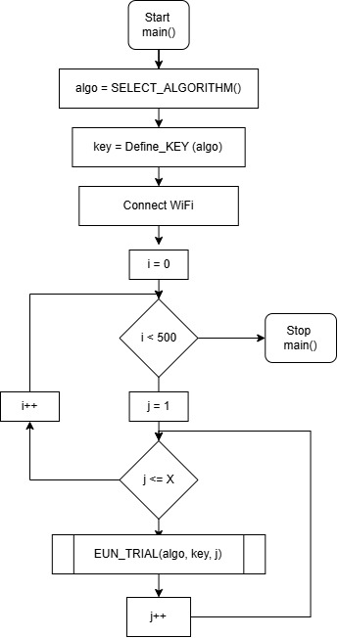
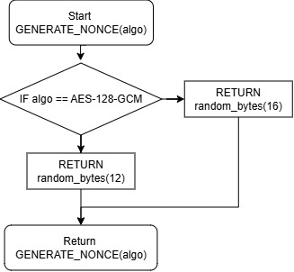
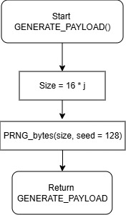
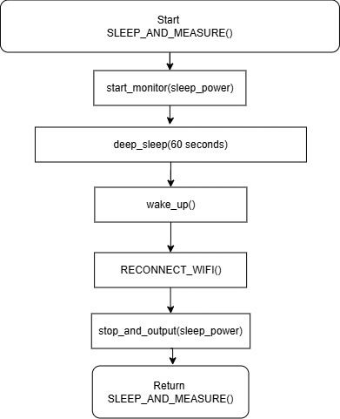
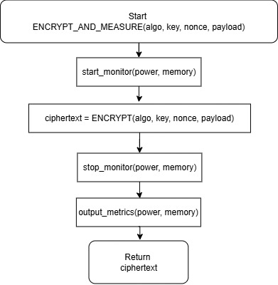
Figure 1 - Main Algorithm
- Reporting: Once the connection is restored, the accumulated metrics are transmitted to a remote Node-RED dashboard for real-time visualization and logging
This integrated approach allows the study to measure the complete energy chain from the initial wake-up and sensing through encryption to the post-sleep reporting providing a comprehensive view of the security-to-battery life trade-off.

3.3.2 Payload Generation Strategy
The payload generation strategy utilizes a benchmarking approach established by [Jin & Becker, 2022] to assess how varying data volumes affect cryptographic resource consumption. The measurement program evaluates 100 specific data points (), starting from a baseline of 16 bytes and incrementing by 16 bytes per step until reaching a maximum payload of 1600 bytes. Each data point is executed and measured 500 times to minimize measurement uncertainty and provide a representative mean latency and power draw.
To ensure reproducibility across experimental runs, a Pseudo-random Number Generator (PRNG) is used, seeded with a constant value of 128. This generator builds data messages where each byte is randomly selected from a pool of numerical characters (0-9) and lowercase alphabets (a-z). This method eliminates the risk that specific, non-random data patterns might artificially bias algorithm performance.

3.3.3 Nonce Generation
The security of both AES-128-GCM and ASCON-128 depends critically on nonce uniqueness to prevent replay attacks and ensure cryptographic integrity. Following the research algorithm, a fresh nonce is generated for every individual message prior to the encryption phase. For the AES-GCM implementation, a 12-byte nonce is generated using the ESP32’s internal cryptographic randomness, consistent with established security standards for Galois Counter Mode. And 16-byte nonce is for ASCON-128 is used as well. This nonce is then cryptographically bound to the resulting ciphertext and subsequently shared during the transmission phase for successful decryption at the gateway.

3.3.4 Duty-Cycle/ Sleep Design
The duty-cycle design is modeled after the environmental monitoring system described by [Syahmi Md Dzahir & Seng Chia, 2023] to simulate realistic IoT behavior. Rather than operating in a continuous active state, the ESP32 is configured to follow a Sleep → Wake → Sense → Encrypt → Transmit → Sleep cycle. In accordance with Syahmi’s methodology, the device enters a deep sleep mode for 60 seconds between each active session to maximize battery longevity. It should be noted that while Syahmi’s original work investigates energy consumption across four distinct conditions by varying both FreeRTOS (on/off) and deep sleep (on/off) states, this research exclusively adopts the deep-sleep dimension of their design, utilizing a bare-metal implementation to isolate cryptographic energy overhead from operating system scheduling noise.
During the active transmission phase, the device utilizes Wi-Fi and the MQTT protocol to share the ciphertext, secret key, and generated nonce with a Node-RED dashboard. This step implements the transmission dimension of the duty cycle, allowing for real-time visualization of the cryptographic data while capturing the significant power draw associated with radio-frequency (RF) operations. By measuring energy across this complete cycle, the research can accurately identify the break-even payload size where hardware-acceleration may become more efficient than lightweight software alternatives.

3.4 Test-bed Implementation
The implementation of the research test-bed is designed to provide a high-precision environment for measuring the cryptographic performance and energy efficiency of the ESP32 platform. This setup integrates standard IoT telemetry components with dedicated power monitoring hardware to capture granular data across the complete duty cycle.

3.4.1 Hardware Components
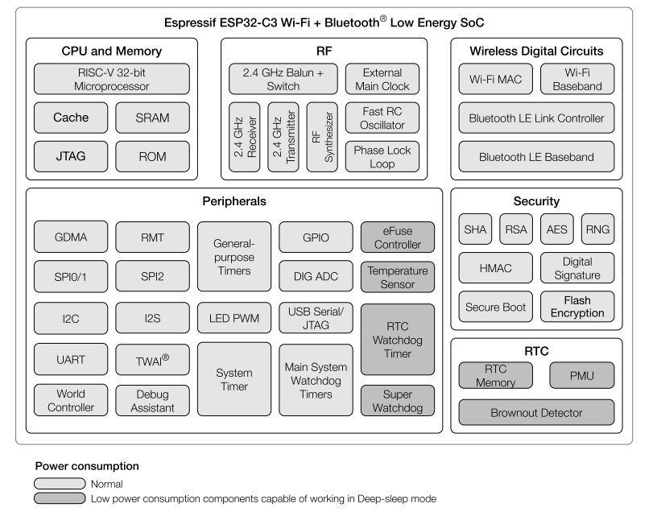
The hardware setup is designed to provide an accurate and stable environment for measuring the cryptographic overhead of the ESP32-WROOM-32E development board, while the INA219 sensor captures energy usage data with high precision.
Figure 2 - Functional Block Diagram of ESP32

ESP32-WROOM-32E Microcontroller
The heart of the test-bed is the ESP32-WROOM-32E a highly integrated System-on-Chip (SoC) designed for low-power IoT applications. It features a dual-core Xtensa 32-bit LX6 microprocessor capable of operating at clock frequencies up to 240MHz, providing ample computational power for handling complex cryptographic tasks in both software and hardware implementations (Mac et al., n.d.).
- Memory and Peripherals: The SoC includes approximately 400 KB of internal SRAM for data and instruction storage and supports external flash memory up to 16 MB. Its integrated Wi-Fi and dual-mode Bluetooth connectivity allow it to function as a standalone MQTT client for real-time telemetry reporting.
- Cryptographic Hardware Acceleration Engine: The ESP32 is distinguished by its dedicated security subsystem, which includes hardware accelerators for widely used algorithms such as AES (128, 192, and 256-bit), SHA, and RSA. This engine works by offloading computationally intensive mathematical operations from the main CPU to specialized silicon blocks. This offloading drastically reduces encryption latency and total energy consumption, as a hardware-based AES operation can execute in a fraction of the time required by a software library. The accelerator can operate in Typical Mode, where the CPU interacts directly with registers, or DMA Mode, which utilizes the General DMA (GDMA) controller to transfer data between RAM and peripherals without continuous CPU intervention.
- Power Management and Deep Sleep: To maximize battery life in realistic IoT duty cycles, the ESP32 utilizes a multi-mode power management unit. The most efficient mode is Deep Sleep, where the CPU, Wi-Fi, and Bluetooth are powered down, leaving only the Ultra-Low-Power (ULP) co-processor or the Real-Time Clock (RTC) active. In this state, the device consumes as little as 5 µA to 10 µA, significantly extending operational longevity compared to continuous active operation. The device can be woken up via a periodic RTC timer or external interrupts, at which point it returns to the active mode to sense and encrypt data.

INA219 Current and Power Monitor
To monitor the energy efficiency of the cryptographic operations, an INA219 current sensor is integrated into the circuit. This device is a high-side, bidirectional current shunt and power monitor with an I2C-compatible interface [Texas Instruments, 2008].
- Operating Mechanism: The INA219 functions by sensing the small voltage drop across a shunt resistor (R_{SHUNT}) placed in series with the load (the ESP32). It simultaneously measures the bus supply voltage (up to 26V) and the differential shunt voltage.
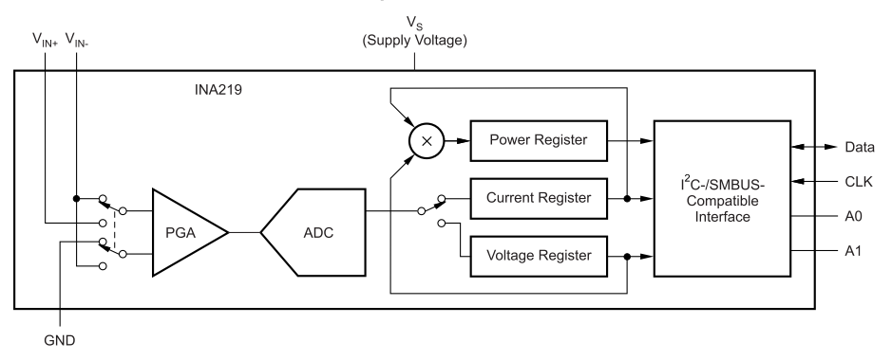
- Data Processing: The sensor features a programmable internal multiplier and calibration registers that allow it to calculate current in amperes and power in watts directly. This data is digitized by an internal 12-bit ADC, allowing the researcher to retrieve granular power consumption metrics via the ESP32’s I²C bus at GPIO 21 (SDA) and GPIO 22 (SCL). This setup provides the microsecond-level precision necessary to capture the transient power spikes associated with hardware-accelerated encryption tasks.
Figure 3 - Simplified Schematic of INA219

Supporting Infrastructure
- Power Supply: The assembly is powered by a regulated 5V DC source. This voltage is stepped down to the 3.3V operating level required by the ESP32 via a buck convertor, ensuring a stable baseline for all current measurements.
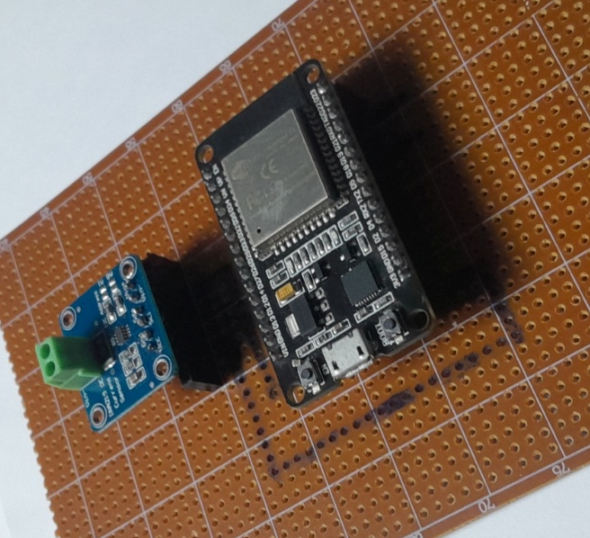

Figure 4 - Test Bed Side View

Software Environment and Libraries
The evaluation is conducted within the ESP-IDF (Espressif IoT Development Framework), the official software development environment for the ESP32 SoC. This framework provides the necessary APIs, scripts, and an integrated development environment (IDE) for developing programs in the ANSI C standard using the gcc compiler. Key software components and libraries utilized include:
Cryptographic Libraries: The mbed TLS library (e.g., version 2.16.2) is employed to handle transport layer security and provide the interface for AES hardware acceleration, which is a native feature of the ESP32. It is critical that the implementation explicitly invokes these hardware peripherals to ensure the system does not default to slower software emulation.
Communication Protocols: Data transmission is managed through the ESP-IDF MQTT library (running version 3.1.1), while the Mosquitto broker (e.g., version 1.6.7) is utilized on the server side to facilitate message distribution.

3.4.3 Schematic Diagram
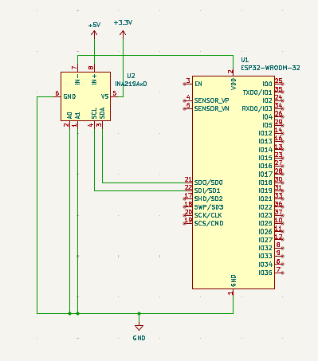
Figure 5 - Schematic Diagram

The Fig 7 schematic diagram illustrates the precise electrical interconnects required to facilitate granular energy profiling of the ESP32-WROOM-32 module using the INA219 current sensor. The design ensures that the cryptographic operations performed by the microcontroller are accurately captured electrical data.
- The circuit is designed for high-side current sensing, where the INA219 is placed between the power source and the load (the ESP32). The +5V supply rail is connected directly to the IN+ (Pin 8) of the INA219.
- The load output N- (Pin 7) of the INA219 is connected to the VDD (Pin 2) of the ESP32. This configuration allows the INA219 to measure the differential voltage drop across its internal shunt resister, which converted into current and power reading.
- To retrieve measurement data, ESP32 functioned as I2C master, communicating with the INA219 as a slave. The SDA (Pin 3) and SCL (Pin 4) pins of the INA219 are interfaced with the ESP32’s GPIO 21 and GPIO 22, respectively.
- The address pins A0 (Pin 2) and A1 (Pin 1) on the INA219 are both tied to GND. According to the INA219 datasheet, this hard-wired configuration sets the unique I2C salve address to 1000000 (0x40), allowing the ESP32 to target the sensor on the bus.
This schematic implementation is critical for the deductive analysis of the research. By measuring the voltage at IN- and the differential voltage between IN+ and IN-, the ESP32 can calculate its own instantaneous power draw during the "Encrypt" and "Transmit" phases of the duty cycle. This setup provides the microsecond-level precision necessary to distinguish between the energy profiles of software-based ASCON-128 and hardware-accelerated AES-128-GCM.

3.4.4 Wiring Diagram and Physical Setup
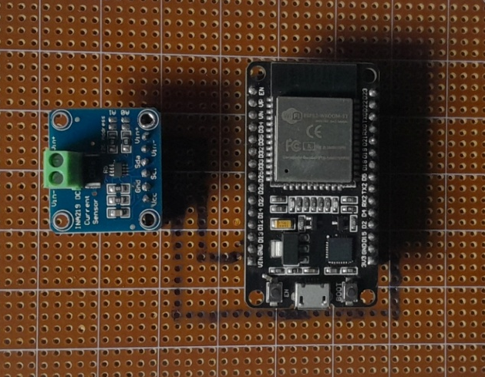
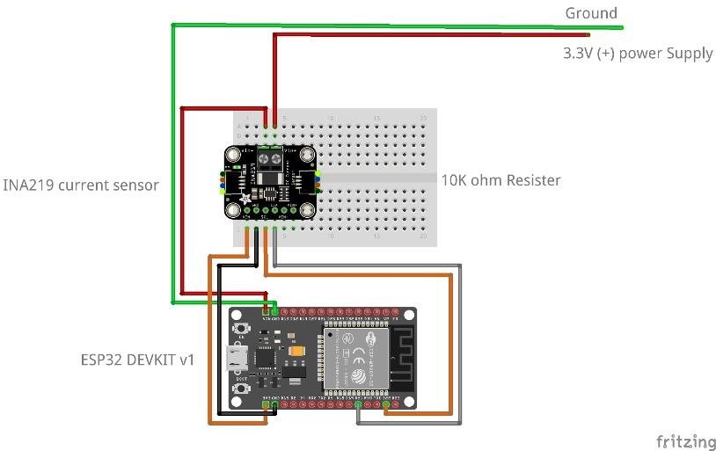
The physical implementation of the test-bed transitions from a temporary prototype to a stable, soldered assembly on a prototyping dot board, as illustrated in the provided hardware documentation. This implementation ensures maximum electrical integrity and minimizes parasitic contact resistance. This permanent setup is critical for the research’s energy-centric evaluation, as it eliminates the risk of power fluctuations or voltages drops cause by loose physical connections.

Figure 6 - Test Bed
As the Fig.7 dipicts the assembly features ESP32-WROOM-32E and INA219 sensor mounted securely on the board, with the sensor positioned in series with the 5v supply rail to capture the differential volatage drop across the internal shunt. The communication lines for the I2C interface (SDA and SCL) are hard-wired between the components, ensuring a reliable data path for real-time power reporting.

3.5 Measurement Methodology

3.5.1 Execution Time Measurement
Execution time is measured using high-resolution hardware timers to isolate the computational latency of the cryptographic primitives from background operating system tasks. Following the methodology established by [Mitchel et al., 2025], the research utilizes the micros() clock API, which provides a precision of one microsecond.
As defined in the research algorithm, the measurement program records a high-precision timestamp immediately before the cryptographic function call and another immediately after the operation concludes. The difference between these two values represents the total latency for that specific payload. To ensure statistical reliability and account for transient system fluctuations, this process is integrated into a nested loop structure: an inner loop () iterates through 100 varying payload sizes, while an outer loop () repeats each test 500 times to establish a stable mean latency for every data point.

3.5.2 Throughput Calculation
Throughput is calculated to quantify the data processing speed of each algorithm, representing the volume of data encrypted or decrypted per unit of time. The calculation follows the standardized mathematical formula utilized in the [Mitchel et al., 2025] research.
The payload size for each calculation is derived from the generation strategy where the data message is defined as 16 bytes x j. Once the 500 execution time samples (in microseconds) are collected for a specific payload size, the researcher calculates the mean time per operation (x). This mean value is then converted into seconds to determine the throughput in bytes per second (B/s) using the following formula:

Throughput(B/s) =
(16 x j) Bytes
Mean Execution Time (Seconds)
Equation 1 - Throughput Equation
By applying this calculation across the entire range of the payload generator (16 to 1600 bytes), this metric allows for a direct, normalized comparison of how effectively the ESP32 hardware engine offloads processing compared to the CPU-bound ASCON-128 software implementation.

3.5.3 Power Consumption Measurement
Power consumption is monitored using the INA219 current sensor, integrated directly into the ESP32 circuit to capture real-time electrical data. This high-precision sensing approach, as utilized by [Rafat et al., 2025] allows for the detection of transient current spikes during active cryptographic tasks.
The total system power is calculated based on the generalized power law, where electrical power () is the product of the constant supply voltage () and the instantaneous current () measured by the INA219.
P = V x I
Equation 2 - Total Power Equation
By maintaining a regulated 5V supply, variations in power draw can be attributed specifically to CPU activity and hardware accelerator utilization.

3.5.4 Memory Footprint Measurement
To assess the memory footprint of cryptographic operations, this methodology adopts the technique established by Matas Pipiras, 2024],which utilizes a controlled experimental environment on an ESP32-based platform (specifically the Pycom FiPy) running MicroPython’s ucrypto library. The measurement process is encapsulated in a specialized helper function, measureRAM(), which estimates usage by capturing snapshots of the system's available memory immediately before and after the execution of the encryption or decryption operation. To ensure high measurement accuracy and prevent data from previous operations from skewing results, the system first invokes gc.collect() to clear unused memory before recording the initial state using gc.mem_free(). The total RAM usage is then calculated by determining the difference between the "before" and "after" memory values. Furthermore, to enhance reliability and minimize the impact of random noise or background system processes, each test configuration is repeated five times, with the median value used for the final analysis.

3.6 Data Collection and Extraction
For the data collection and extraction phase, the methodology follows a structured process of capturing real-time metrics and logging them for evaluations later. Following the execution of each cryptographic operation, performance metrics specifically execution time and memory usage are generated by the microcontroller and transmitted to an external listener. In studies involving ESP32-based platforms, these results are typically published via protocols like MQTT or printed directly to a serial console. As specified in your experimental setup, these metrics are outputted to the ESP-IDF console, where the raw data is captured and saved into a text file.
Once the iterations are complete, the saved output undergoes a data extraction and cleaning process to ensure accuracy. Similar to the analysis techniques used by [Matas Pipiras, 2024;Mitchel et al., 2025], the raw logs are processed to remove noise and formatted into structured files, such as CSV, for easier handling. This structured data is then used to perform statistical analysis, which includes calculating the median or mean values to mitigate the impact of random spikes or background system processes. Finally, the cleaned data is visualized through tables and graphs to identify performance trends across different encryption modes and payload sizes.

3.7 Expected Data Analysis and Statistical Evaluation

3.7.1 Statistical Methods and Tools
The data analysis phase involves processing raw performance metrics captured during the experimental trials. Initial data collection results in raw logs containing execution times and memory snapshots, which are subsequently cleaned and structured into CSV files for systematic evaluation. To ensure the reliability of the results and mitigate the impact of random noise, such as background system processes or network activity, each test configuration is subjected to multiple iterations.
- The median value is utilized to represent typical performance, as it effectively reduces the skewing effect of irregular spikes in execution time. For large-scale datasets involving 1000+ iterations, the mean execution time and throughput (Bytes per second) are also calculated to provide a comprehensive view of performance.
- Standard deviation and 95% confidence intervals are computed to quantify the variability between iterations.
- The statistical analysis is facilitated by the Python library SciPy for evaluating p-values and cleaning raw serial communication data [Mitchel et al., 2025].

3.7.2 Significance/Comparison Method
To evaluate the performance trade-offs between different cryptographic configurations, the study employs several comparative techniques:
Hypothesis Testing: One-tailed independent t-tests are conducted to determine if the observed performance differences between algorithms (e.g., comparing ASCON to AES counterparts) are statistically significant, typically using a significance level of α = 0.01.
Regression and Scaling Analysis: For metrics that change based on data size, such as RAM usage or associated data (AD) runtime, the study utilizes linear regression. The coefficient of determination (R²) is used to confirm how closely the performance follows a linear growth pattern as payload sizes increase.
Data Visualization: Comparative findings are illustrated through bar charts for discrete category comparisons (like execution time across different AES modes) and scatter plots or line graphs to visualize scaling trends.

11. References
[Agugliaro et al., 2024] | Agugliaro, F. M., Soto-Cruz, J., Ruiz-Ibarra, E., Vázquez-Castillo, J., Espinoza-Ruiz, A., Castillo-Atoche, A., & Mass-Sanchez, J. (2024). A Survey of Efficient Lightweight Cryptography for Power-Constrained Microcontrollers. Technologies. https://doi.org/10.3390/technologies
[Albert, 2026] | Albert, B. (2026). Energy-Efficient Cryptographic Protocols for Securing Low-Power IoT Networks.
[Arghire, 2024] | Arghire, I. (2024, April 25). SecurityWeek. Retrieved from data protection: https://www.securityweek.com/ftc-sending-5-6-million-in-refunds-to-ring-customers-over-security-failures/
[Al-Mashhadani & Shujaa, 2022] | Al-Mashhadani, M., & Shujaa, M. (2022). IoT Security Using AES Encryption Technology based ESP32 Platform. International Arab Journal of Information Technology, 19(2), 214–223. https://doi.org/10.34028/iajit/19/2/8
[Al-Shmailawi et al., 2026] | Al-Shmailawi, H. A., Al-Hemiary, E. H., & Sikora, A. (2026). Evaluation of NIST Lightweight Cryptography Algorithms for Industrial Internet of Things. 49–55. https://doi.org/10.1109/idaacs68557.2025.11322258
[Amirkhanova et al., 2026] | Amirkhanova, G., Ismailov, S., Amirkhanov, A., Adilzhanova, S., Zhasuzakova, M., & Chen, S. (2026a). A Lightweight, End-to-End Encrypted Data Pipeline for IIoT: An AES-GCM Implementation for ESP32, MQTT, and Raspberry Pi. Information, 17(1), 33. https://doi.org/10.3390/info17010033
[Aydin et al., 2011] | Aydin, N., Karaca, M., & Ercetin, O. (2011). Energy-Optimal Scheduling in Low Duty Cycle Sensor Networks. http://arxiv.org/abs/1103.3616
[Beaulieu et al., 2013] | Beaulieu, R., Shors, D., Smith, J., Treatman-Clark, S., Weeks, B., & Wingers, L. (2013). The Simon and Speck Families of Lightweight Block Ciphers
[Bideh et al., 2020] | Bideh, P. N., Sönnerup, J., & Hell, M. (2020, October 6). Energy consumption for securing lightweight IoT protocols. ACM International Conference Proceeding Series. https://doi.org/10.1145/3410992.3411008
[Chen & Scholl, 2022] | Chen, L., & Scholl, M. (2022, May 26). The Cornerstone of Cybersecurity – Cryptographic Standards and a 50 Year Evolution. Retrieved from NCCoE (National Cybersecurity Center of Excellence), NIST: https://www.nccoe.nist.gov/news-insights/cornerstone-cybersecurity-cryptographic-standards-and-50-year-evolution
[Ciuffoletti, 2022] | Ciuffoletti, A. (2022). Deep-Sleep for Stateful IoT Edge Devices. Information (Switzerland), 13(3). https://doi.org/10.3390/info13030156
[Community, 2026] | Community, H. N. (2026). How to Profile ESP32 Power Consumption Accurately. Retrieved from Hubble Network Community: https://hubble.com/community/guides/how-to-profile-esp32-power-consumption-accurately/
[Devadas et al., 2022] | Devadas, S., Langowski, S., Samardzic, N., Servan-Schreiber, S., & Sanchez, D. (2022). Designing Hardware for Cryptography and Cryptography for Hardware. Proceedings of the ACM Conference on Computer and Communications Security, 1–4. https://doi.org/10.1145/3548606.3559393
[Dezfouli et al., 2018] | Dezfouli, B., Amirtharaj, I., & Li, C.-C. (2018). EMPIOT: An Energy Measurement Platform for Wireless IoT Devices. Journal of Network and Computer Applications, 121.
[Elsadek, 2025] | Elsadek, I. e. (2025). State-of-the-Art ASCON ASIC Achieving 4.3 Gbps@0.8V and 3.5Tb/J@0.6V Outperforming AES by 25 Times. IEEE Transactions on Circuits and Systems I: Regular Papers, 72(8), 4021–4030. doi:10.1109/TCSI.2024.3522193
[Faisal Abdullah Althobaiti, 2025] | Faisal Abdullah Althobaiti. (2025). Lightweight cryptography for IoT: A comprehensive survey of algorithms, implementations, and standardization. World Journal of Advanced Engineering Technology and Sciences, 15(3), 516–525. https://doi.org/10.30574/wjaets.2025.15.3.0967
[Farooq et al., 2020] | Farooq, U., Mushtaq, M., Bhatti, M., & Khurram Bhatti, M. (2020). Efficient AES Implementation for Better Resource Usage and Performance of IoTs. https://hal.archives-ouvertes.fr/hal-02979423
[Fernández-García & Jiménez-Fernández, 2024] | Fernández-García, C., & Jiménez-Fernández, C. J. (n.d.). Study and applications of the new NIST lightweight encryption with authentication standard in hardware implementations.
[Fortinet, 2024] | Fortinet. (2024). What is the CIA Triad and Why is it important? Fortinet Cyberglossary. Retrieved from: https://www.fortinet.com/resources/cyberglossary/cia-triad
[Gerndt et al., 2025] | Gerndt, M., Ispir, M., Nunez, I., & Benedict, S. (2025). Energy-Aware Duty Cycle Management for Solar-Powered IoT Devices. Sensors, 25(14). https://doi.org/10.3390/s25144500
[Hatch, 2025] | Hatch, D. B. (2025). Optimized Wireless Power Transmission for Low-Cost, Energy-Efficient Internet of Things Devices in Residential Environments. https://scholarsarchive.byu.edu/etd/10877
[Hung & Hsu, 2018] | Hung, C. W., & Hsu, W. T. (2018). Power consumption and calculation requirement analysis of AES for WSN IoT. Sensors (Switzerland), 18(6). https://doi.org/10.3390/s18061675
[Mahdi & Abdullah, 2025] | Ibrahim, F., Rehman, A., Hassan, A., & Alzghoul, A. (n.d.). Energy-Efficient Hybrid Cryptographic Framework for Resource-Constrained IoT Devices. ISSN (e) 3007-3138 (p) 3007-312X. https://doi.org/10.5281/zenodo.18047723
[Jin & Becker, 2022] | Jin, Q., & Becker, M. (2022). Performance Evaluation of Cryptographic Algorithms on ESP32 with Cryptographic Hardware Acceleration Feature
[Junchao Ma, 2009] | Junchao Ma, W. Lou. (2009). Energy Efficient TDMA Sleep Scheduling in Wireless Sensor Networks. IEEE
[Kandi et al., 2023] | Kandi, A., Baksi, A., Gerlich, T., Guilley, S., Gan, P., Breier, J., Chattopadhyay, A., Ranjan Shrivastwa, R., Martinasek, Z., & Bhasin, S. (2023). Hardware Implementation of ASCON. https://github.com/aneeshkandi14/ascon-hw-public
[Khriji et al., 2022] | Khriji, S., Chéour, R., & Kanoun, O. (2022). Dynamic Voltage and Frequency Scaling and Duty-Cycling for Ultra Low-Power Wireless Sensor Nodes. Electronics (Switzerland), 11(24). https://doi.org/10.3390/electronics11244071
[Kietzmann et al., 2021] | Kietzmann, P., Boeckmann, L., Lanzieri, L., Schmidt, T. C., & Ahlisch, M. W. (n.d.). A Performance Study of Crypto-Hardware in the Low-end IoT. Retrieved from: https://github.com/
[Kim et al., 2020] | Kim, K., Choi, S., Kwon, H., Kim, H., Liu, Z., & Seo, H. (2020). PAGE-Practical AES-GCM encryption for low-end microcontrollers. Applied Sciences (Switzerland), 10(9). https://doi.org/10.3390/app10093131
[Kozłowski & Sosnowski, 2019] | Kozłowski, A., & Sosnowski, J. (2019). Energy Efficiency Trade-Off Between Duty-Cycling and Wake-Up Radio Techniques in IoT Networks. Wireless Personal Communications, 107(4), 1951–1971. https://doi.org/10.1007/s11277-019-06368-0
[Kumar & Sethi Ericsson, 2019] | Kumar, S., & Sethi Ericsson, M. (2019). Internet of Things Security: State of the Art and Challenges. https://trustee.ietf.org/license-info
[Mac et al., n.d.] | Mac, W.-F., Baseband, W.-F., Le Link Controller, B., & Le Baseband, B. (n.d.). ESP32-C3 Series Datasheet
[Mahdi & Abdullah, 2025] | Mahdi, L. H., & Abdullah, A. A. (2025). A Hybrid Post-Quantum Cryptographic Framework Integrating Kyber-512 and ASCON for Secure IoT Communications. Engineering, Technology and Applied Science Research, 15(5), 26527–26533. https://doi.org/10.48084/etasr.12471
[Matas Pipiras, 2024] | Matas Pipiras. (2024). Performance Analysis of AES Modes of Operation on an ESP32-based Platform - A Comparison of Execution time and RAM Usage in IoT Context
[Mitchel et al., 2025] | Mitchel, R., Ryan, J., Kaiser, A. M., & Hoiness, G. W. (2025). Throughput of ASCON Compared with Popular IoT Encryption Algorithms. Military Cyber Affairs, 8. https://digitalcommons.usf.edu/mca/vol8/iss1/3
[Nkemeni et al., 2023] | Nkemeni, V., Mieyeville, F., & Tsafack, P. (2023). Energy Consumption Reduction in Wireless Sensor Network-Based Water Pipeline Monitoring Systems via Energy Conservation Techniques. Future Internet, 15(12). https://doi.org/10.3390/fi15120402
[Padmanabha1 et al., 2025] | Padmanabha, P., Srinivas, S., Sunil, S., Yasha, D., & Shirur, J. M. (2025). ASIC-Oriented RTL Implementation of ASCON-128 for IoT Devices. International Journal of Science and Engineering Invention (IJSEI), 11(10). https://doi.org/10.23958/ijsei/vol11-i10/298
[Radhakrishnan et al., 2024] | Radhakrishnan, I., Jadon, S., & Honnavalli, P. B. (2024). Efficiency and Security Evaluation of Lightweight Cryptographic Algorithms for Resource-Constrained IoT Devices. Sensors, 24(12). https://doi.org/10.3390/s24124008
[Rafat et al., 2025] | Rafat, S. H., Jarin, M. N., Mahdee, T. M., Miah, A. S. M., Haque, N., Tusher, M. M. R., Shin, J., & Ahmed, I. (2025). Lightweight Cryptographic Algorithm Analysis for Secure IoT Communication on ESP-32 Platforms. 2025 IEEE International Conference on Quantum Photonics, Artificial Intelligence, and Networking, QPAIN 2025. https://doi.org/10.1109/QPAIN66474.2025.11171742
[Ridho Rabbani, 2025] | Ridho Rabbani, M. (2025). Performance Benchmarking Analysis of ASCON and AES-128 Lightweight Cryptography Primitives on ESP32 Hardware.
[Sadhu et al., 2022] | Sadhu, P. K., Yanambaka, V. P., & Abdelgawad, A. (2022). Internet of Things: Security and Solutions Survey. Sensors, 22(19). MDPI. https://doi.org/10.3390/s22197433
[Schneider, 2024] | Schneider, J. (2024). The History of Cryptography. IBM Think. Retrieved from: https://www.ibm.com/think/topics/cryptography-history
[Sinha, 2025] | Sinha, S. (2025, October). State of IoT 2025: Number of connected IoT devices growing 14% to 21.1 billion globally. IoT Analytics
[Syahmi Md Dzahir & Seng Chia, 2023] | Syahmi Md Dzahir, M. A., & Seng Chia, K. (2023). of ESP32 Microcontroller for Real-Time MQTT IoT-Based Monitoring System. 2023 International Conference on Innovation and Intelligence for Informatics, Computing, and Technologies, 3ICT 2023, 255–261. https://doi.org/10.1109/3ICT60104.2023.10391358
[Texas Instruments, 2008] | Texas Instruments. (2008). INA219 Data Sheet. www.ti.com
[F. Thabit, 2023] | F. Thabit, O. C.-G. (2023). Cryptography Algorithms for Enhancing IoT Security. 100759.
[Trap, 2025] | Trap, C. (2025, January 24). Securing the Digital Age: A Deep Dive into Data Encryption Techniques. Canary Trap. Retrieved from: https://canarytrap.com/blog/securing-the-digital-age/
[Tripathi et al., 2024] | Tripathi, Dr. D. R., Akhtar, H. N. N., & Bhandarkar, R. R. (2024). Enhancing IOT Security: Investigating Lightweight Encryption Algorithms for Resource-Constrained Devices. International Journal for Research in Applied Science and Engineering Technology, 12(10), 350–357. https://doi.org/10.22214/ijraset.2024.64519
[Turan et al., 2025] | Turan, M. S., McKay, K. A., Chang, D., Kang, J., & Kelsey, J. (2025). Ascon-based lightweight cryptography standards for constrained devices. NIST. https://doi.org/10.6028/NIST.SP.800-232

